1. Problem Statement & Objectives
Businesses face significant revenue loss due to customer churn, often without early warning signals.
Traditional methods rely on reactive strategies, identifying churn only after it occurs.
Large volumes of customer data make it difficult to manually detect churn patterns.
Lack of real-time insights prevents timely intervention for at-risk customers.
Model performance degrades over time due to changing customer behavior (data drift).
There is a need for an automated, scalable system to predict churn and maintain accuracy continuously.

Solution
Develop a machine learning-based system that predicts customer churn probability using historical and behavioral data.
Provide actionable insights, dashboards, and alerts to help businesses take proactive retention actions.
Implement automated monitoring and retraining to ensure sustained model performance over time.

1.1. Functional Requirements

Functional requirements define what the system must do — the specific features and behaviors it must provide to its users.

# | Requirement | Description | Example
FR-01 | Data Input | The system must support loading customer data from multiple sources including CSV files and databases. | A user uploads a CSV file containing customer age, usage behavior, and complaint history.
FR-02 | Data Processing | The system must automatically clean and prepare data before model execution, including handling missing values and encoding categorical variables. | A column with missing values is filled using the median; text categories are converted to numeric format.
FR-03 | Model Prediction | The system must run a machine learning model to generate a churn probability score for each customer. | Customer ID 456 receives a churn probability score of 0.82, indicating high risk.
FR-04 | Dashboard & Visualization | The system must present prediction results in a visual and easy-to-read dashboard, including charts and ranked customer lists. | A bar chart displays the monthly churn rate alongside a sorted list of the top 20 high-risk customers.
FR-05 | Alerts System | The system must automatically generate alerts when a customer's churn probability exceeds a defined threshold. | An alert is triggered: "Customer ID 123 has a churn probability of 85%. Immediate action recommended."
FR-06 | Export Results | The system must allow users to export prediction results and reports in standard formats. | A marketing analyst exports the high-risk customer list as a CSV file to use in a campaign tool.
FR-07 | Prediction Explainability | Each prediction must include the top contributing factors that influenced the churn score. | The system displays: "Risk Factors: No login in 40 days, 3 unresolved complaints, downgraded plan."
FR-08 | User Authentication & Access Control | The system must support secure login with role-based access control to restrict data visibility by user type. | A marketing analyst can view predictions and export results but cannot access raw customer records or modify the model.

1.2. Non-Functional Requirements

Non-functional requirements define how well the system must perform. They cover quality standards such as speed, security, ease of use, and availability.

Category | Requirement | Measure / Standard
Performance | The system must handle large datasets efficiently, supporting 100,000+ customer records without significant degradation in response time. | Batch predictions for 100k records completed within 5 minutes; on-demand queries return in under 3 seconds.
Security | All customer data must be securely handled using encryption at rest and in transit. Access must be restricted to authorized users only. | AES-256 encryption at rest; TLS 1.3 in transit; authentication via Cloud Identity Service.
Usability | The dashboard must be simple and intuitive, allowing non-technical users to interpret results without any specialized training. | Business managers and support agents can navigate core features within 30 minutes of first use.
Reliability | The system must maintain high availability to ensure predictions and services are consistently accessible. | Minimum 99.9% uptime; automatic failover in the event of a primary server failure.

Use Case Diagram
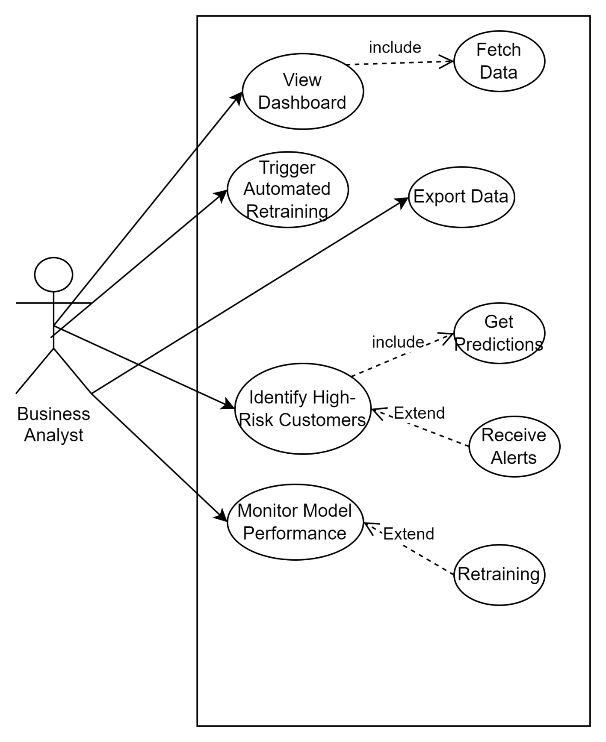

Software Architecture
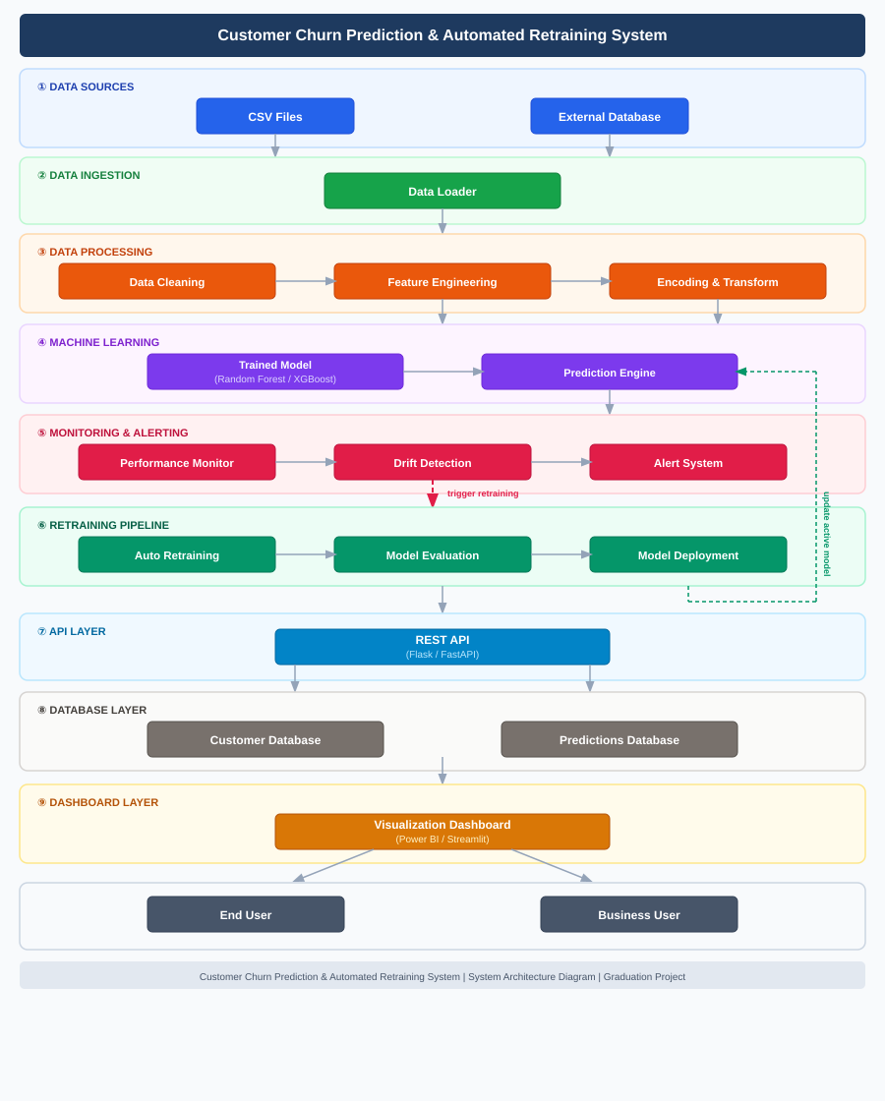

2. Data Flow & System Behavior
- DFD (Data Flow Diagram)
DFD Level 0
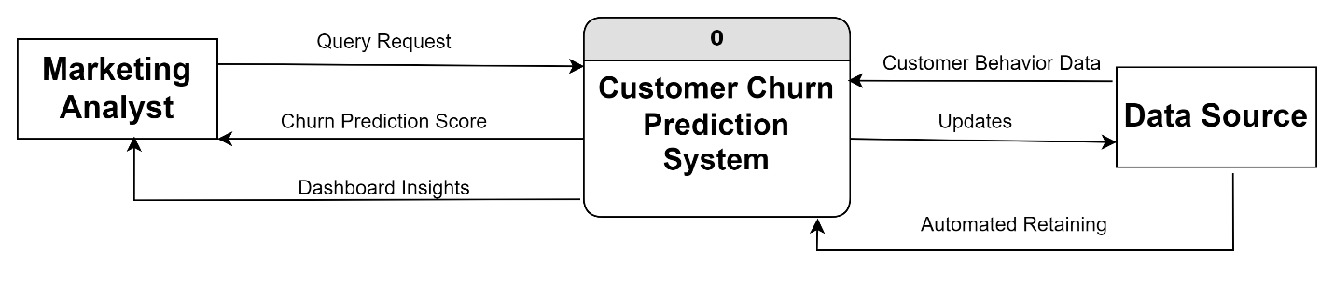
DFD level 1
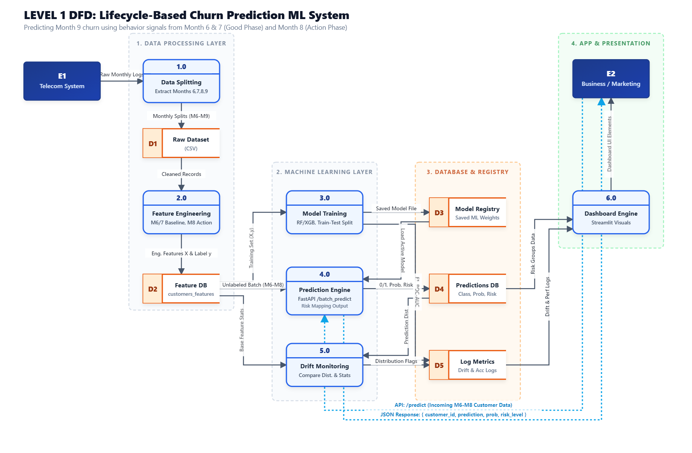

Sequence Diagrams

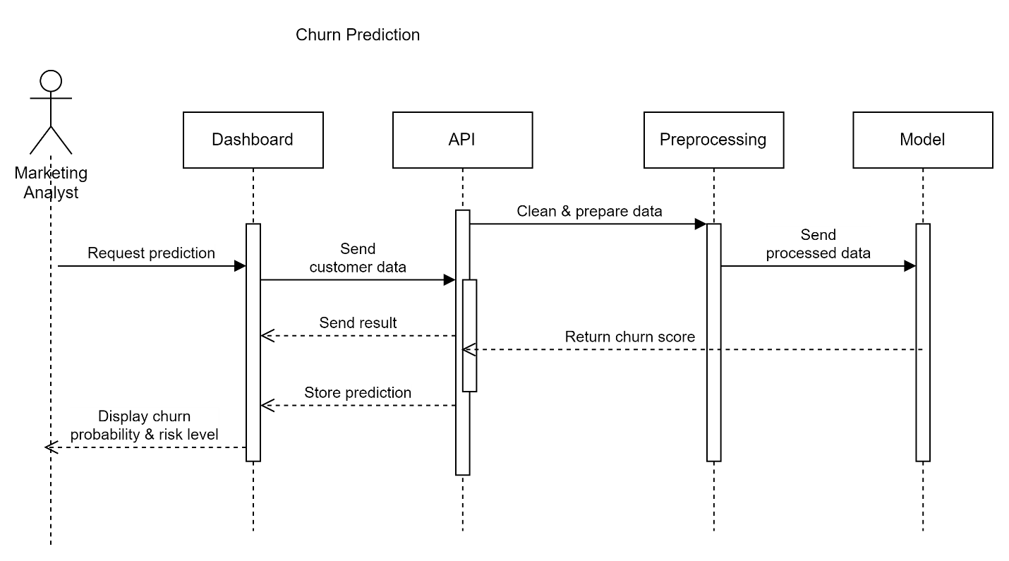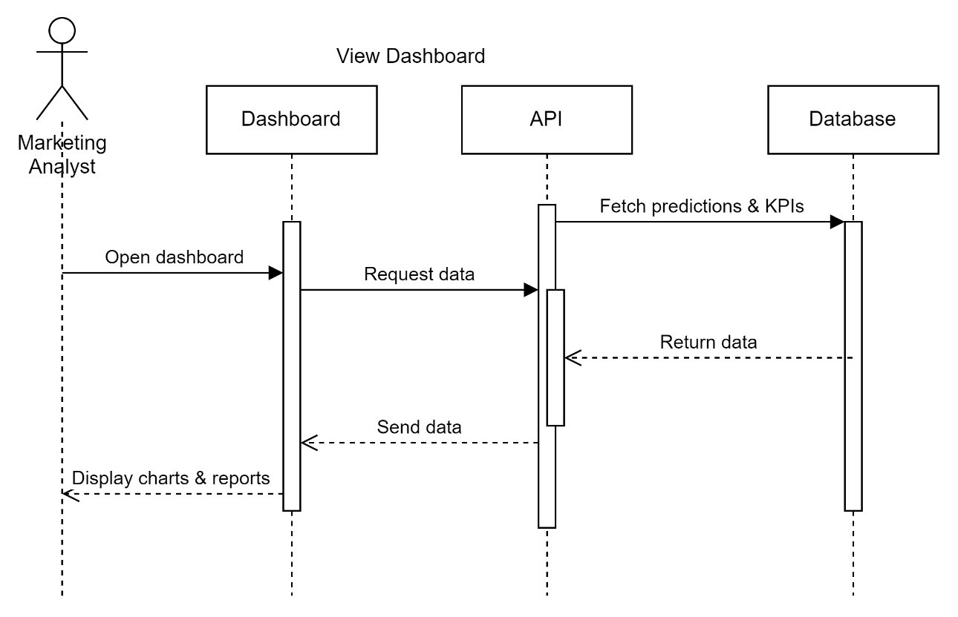

Alerts system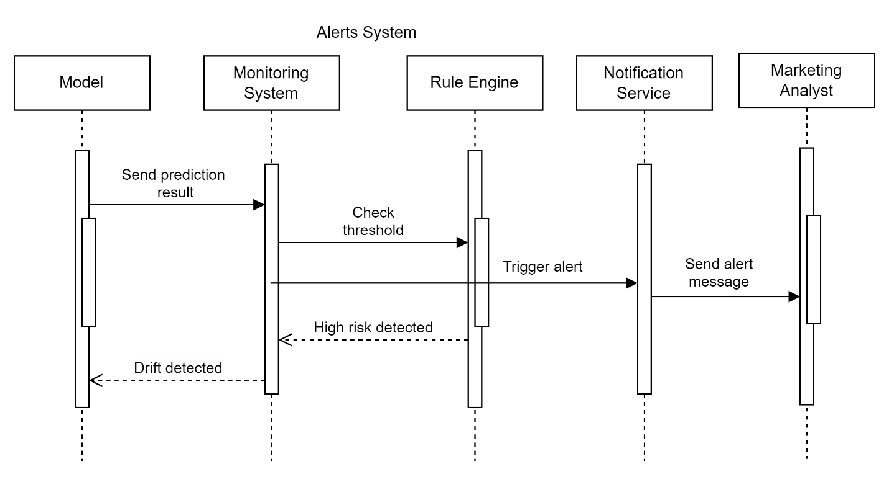

Automated Retraining Diagram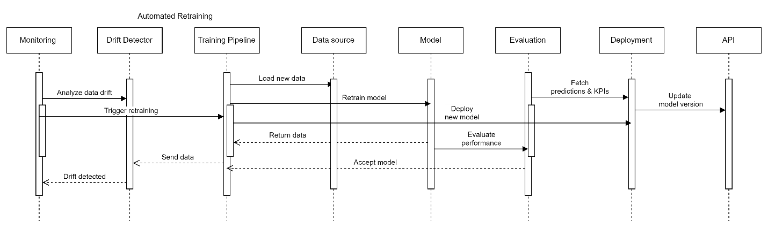

Activity Diagram
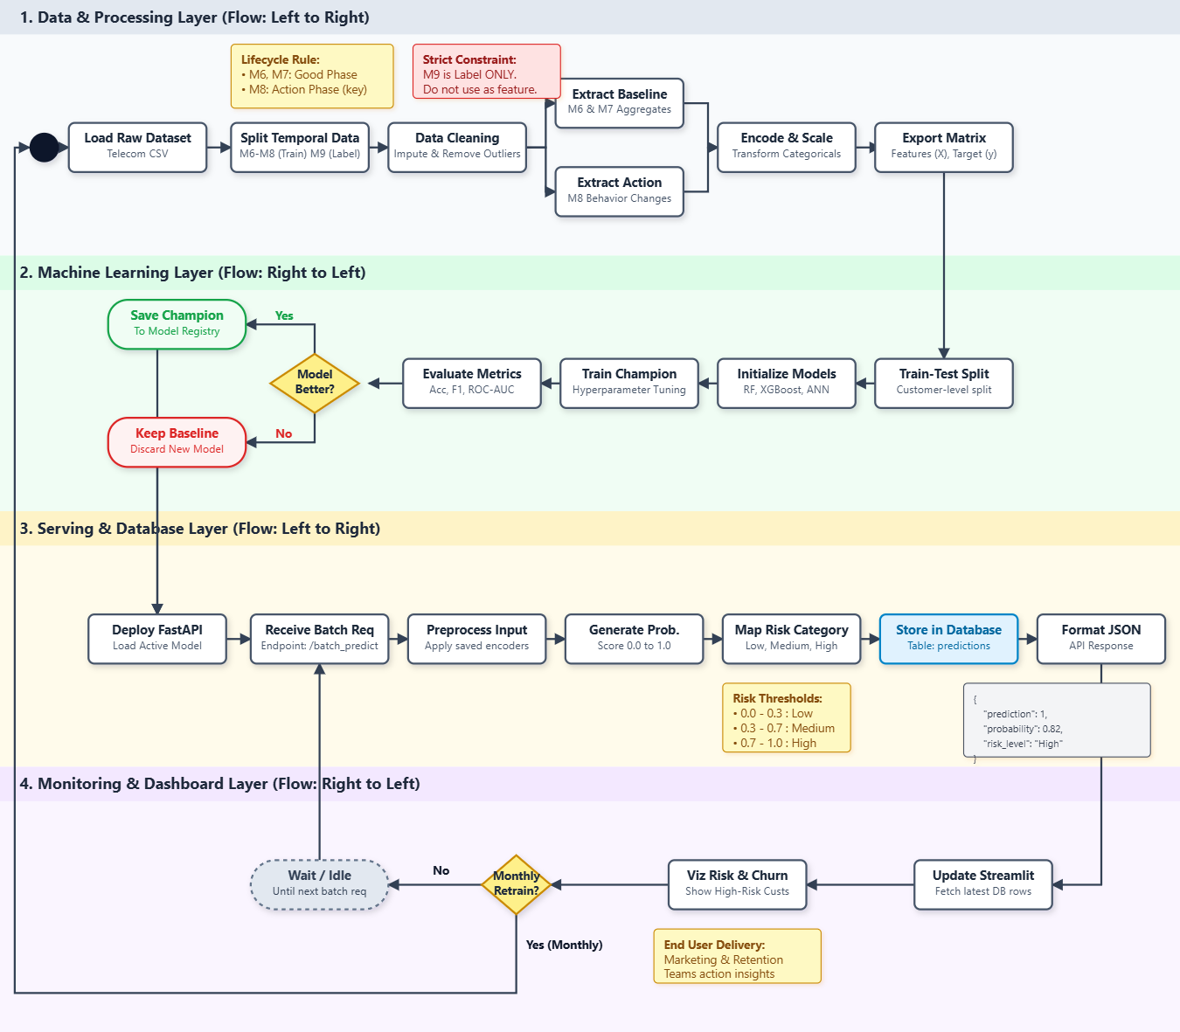

State Diagram
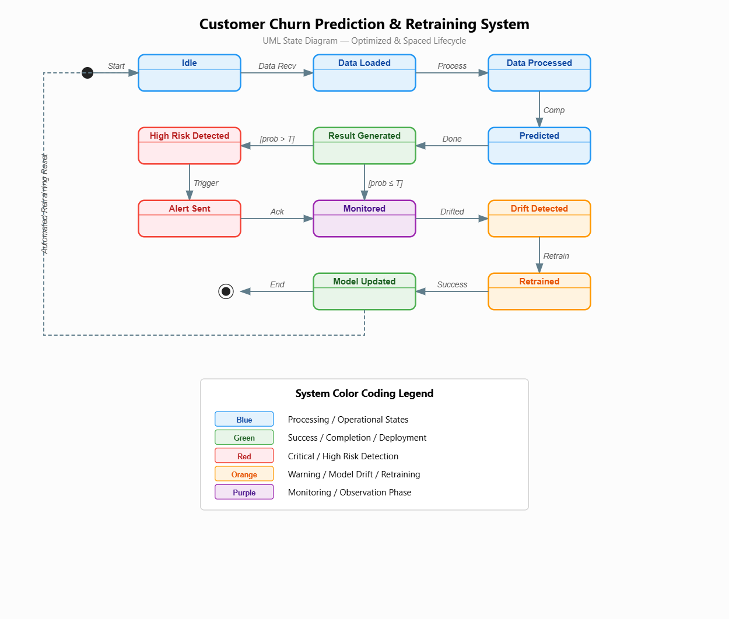

Wireframe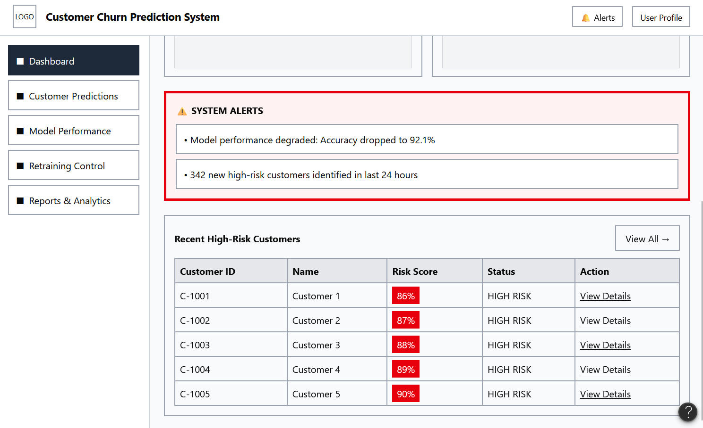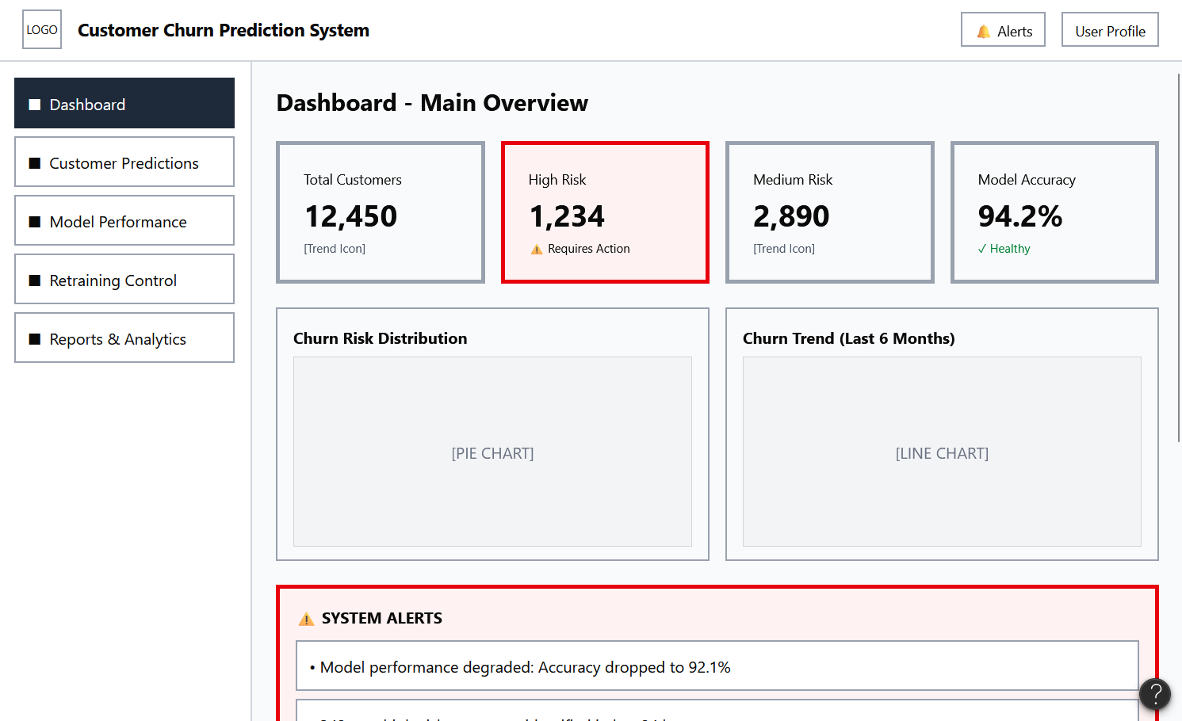
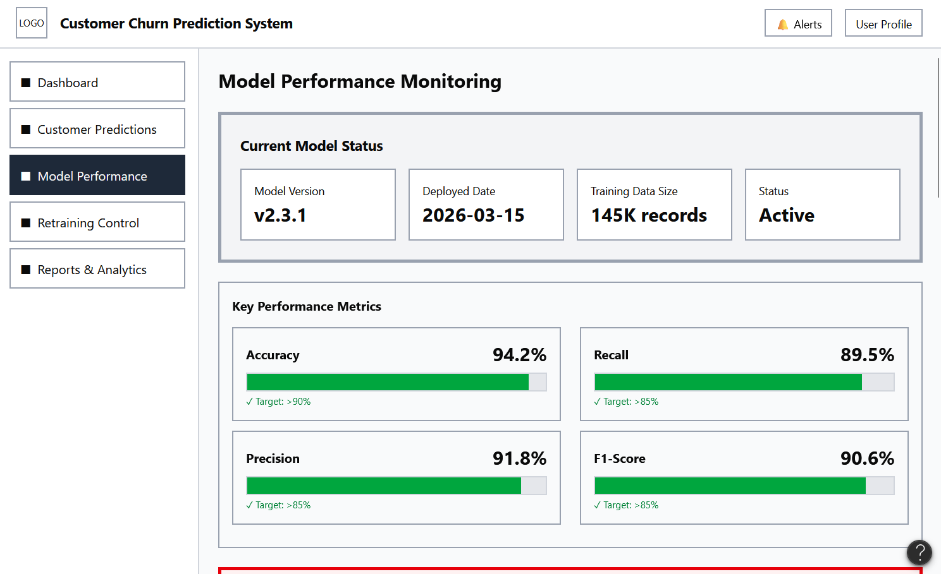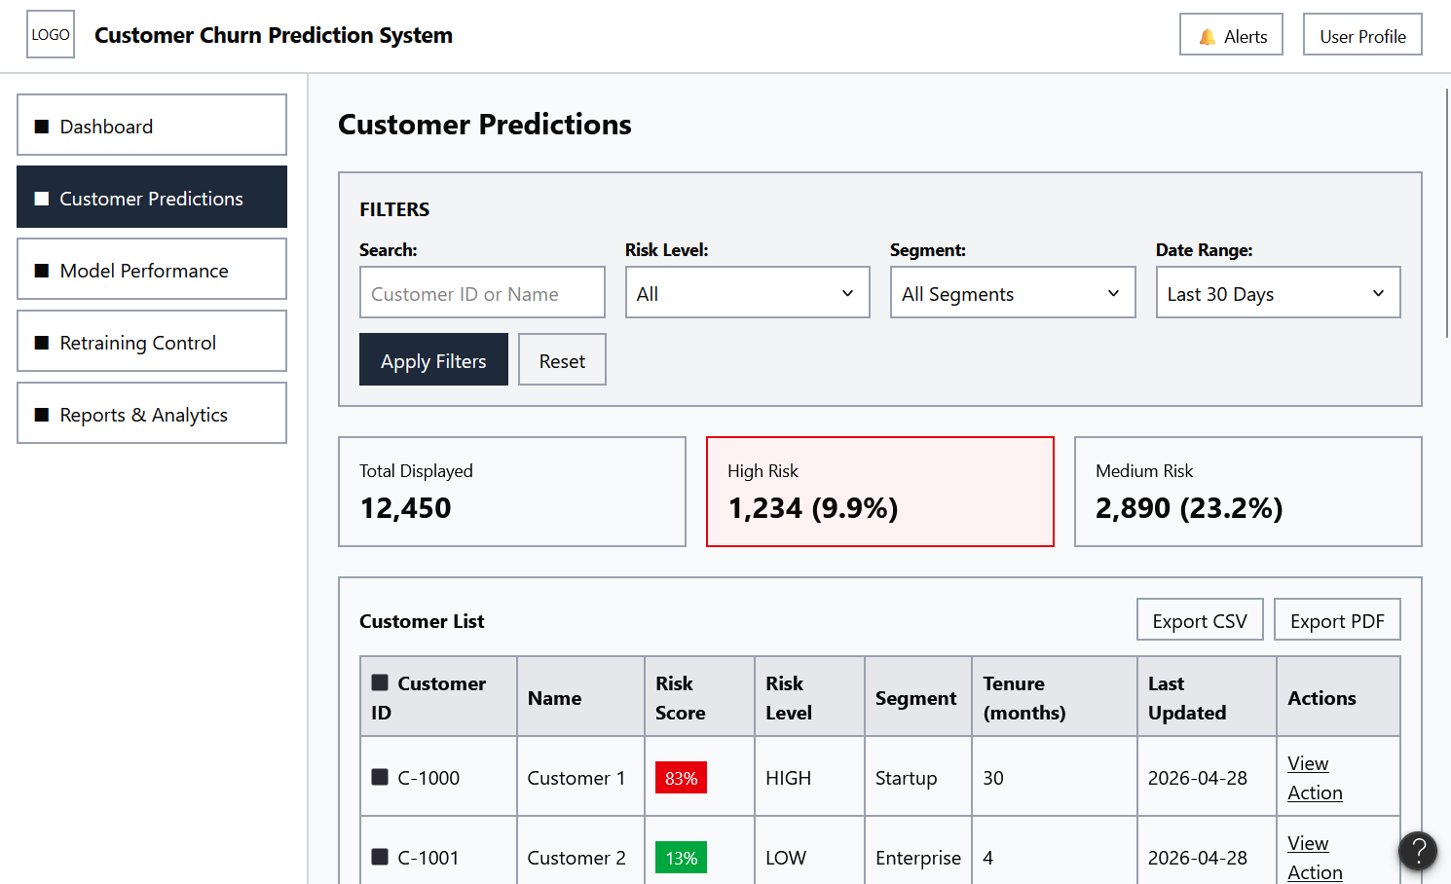
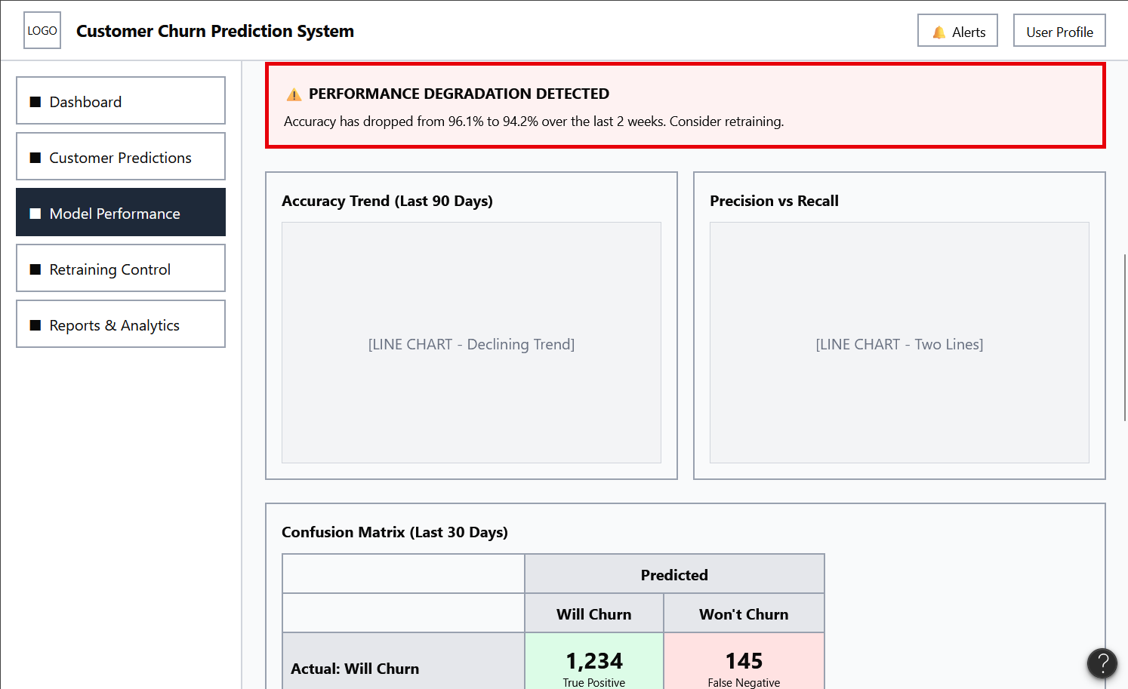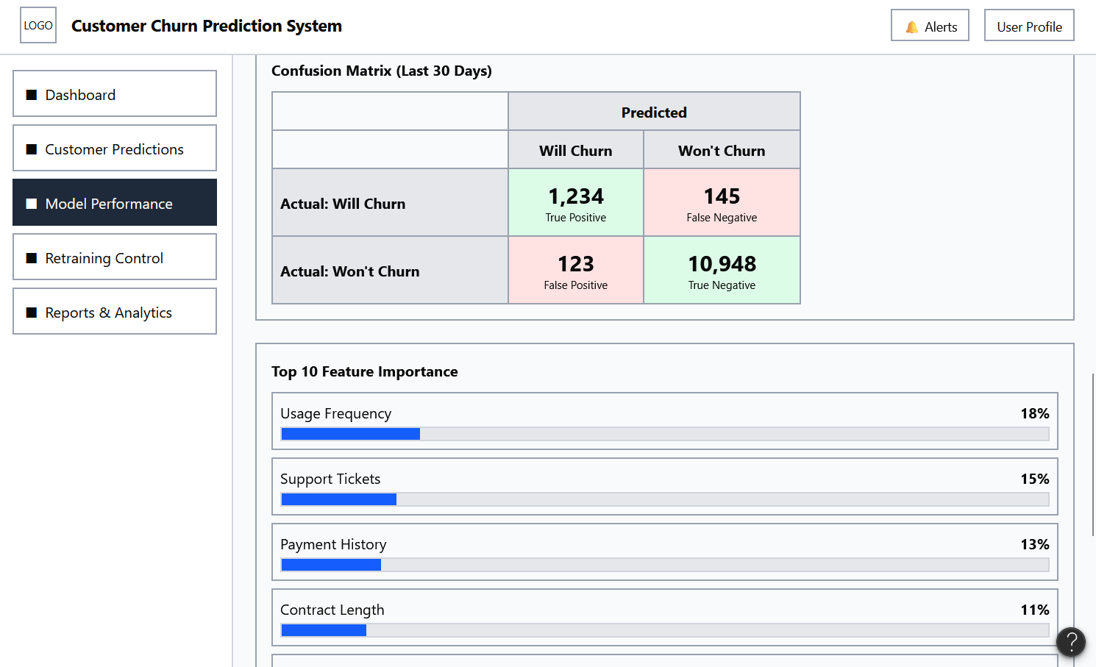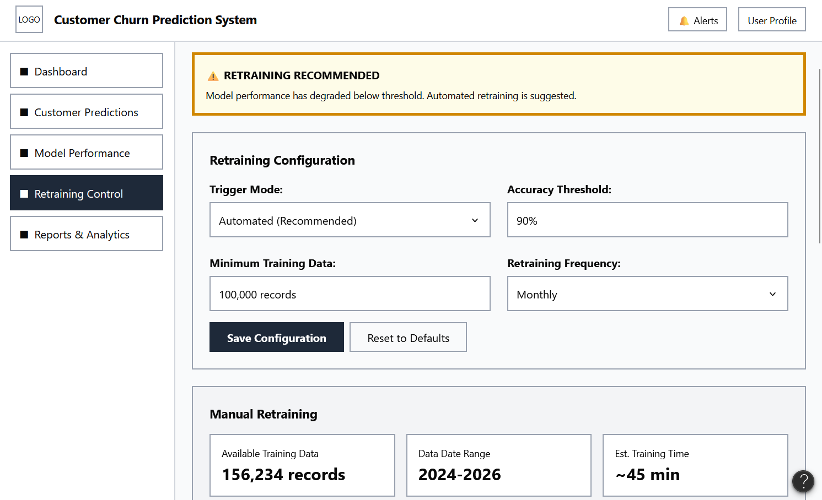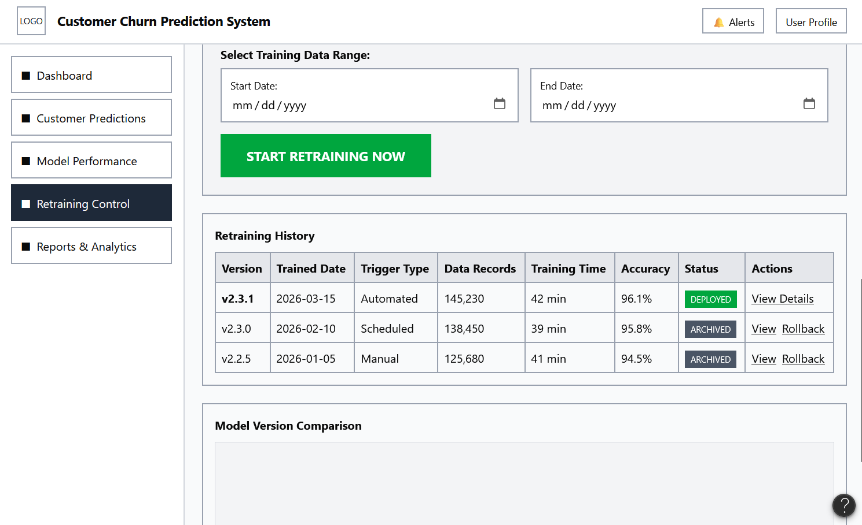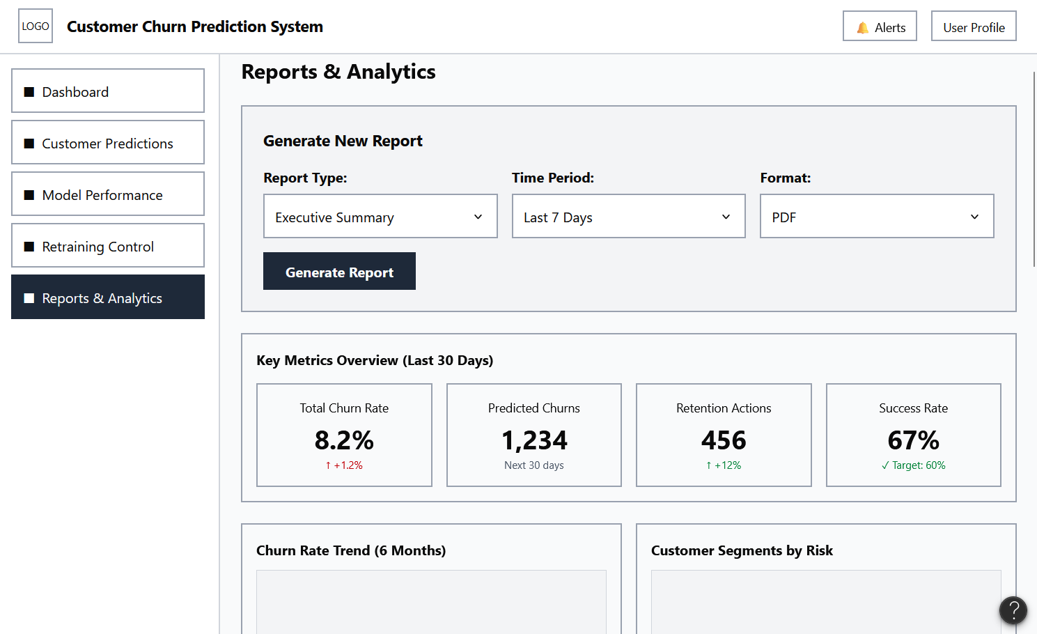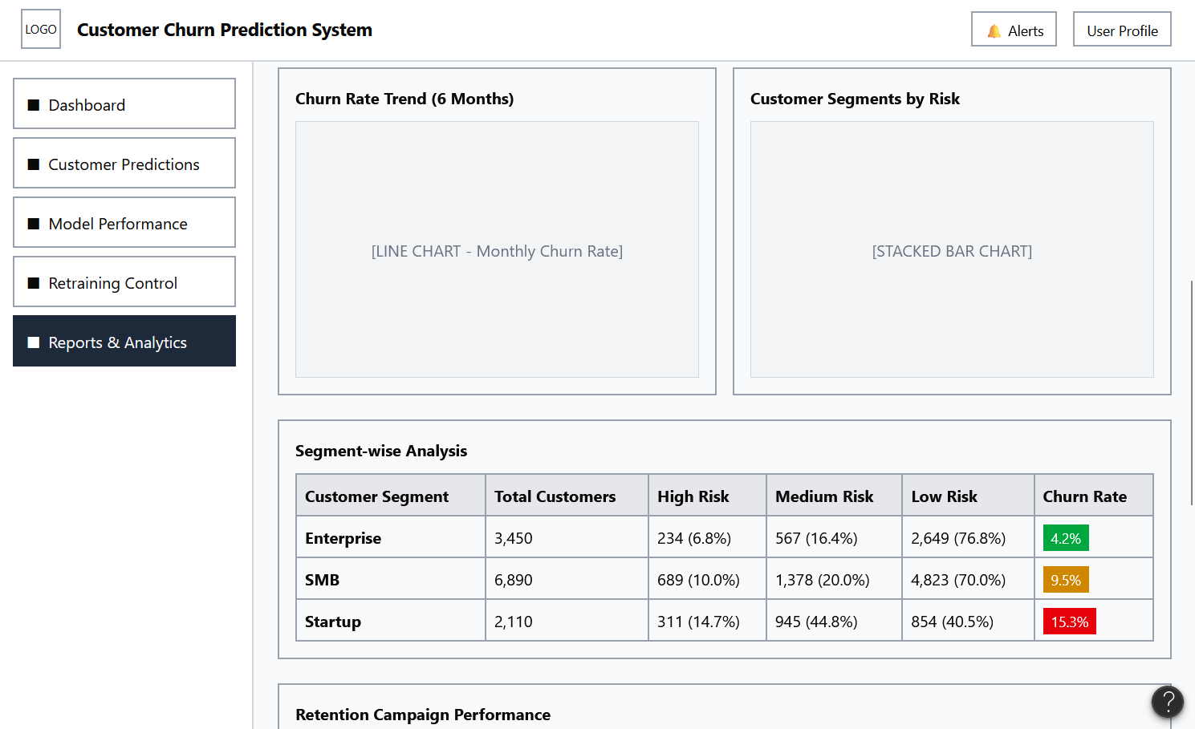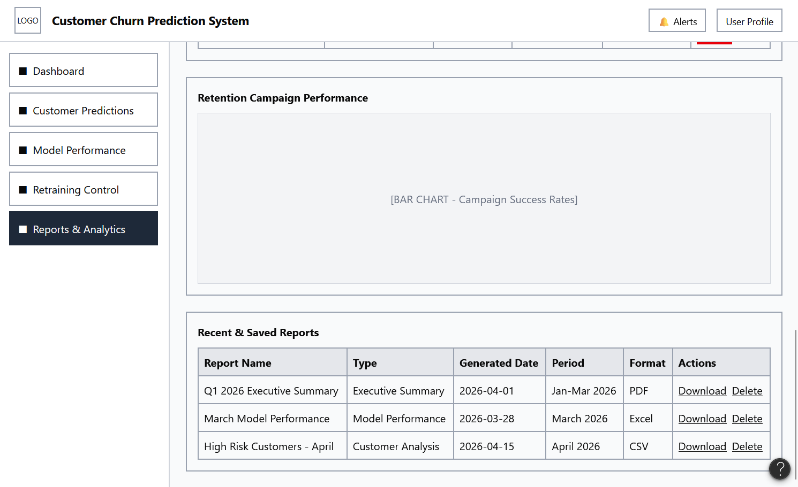

3. UI/UX Design & Prototyping
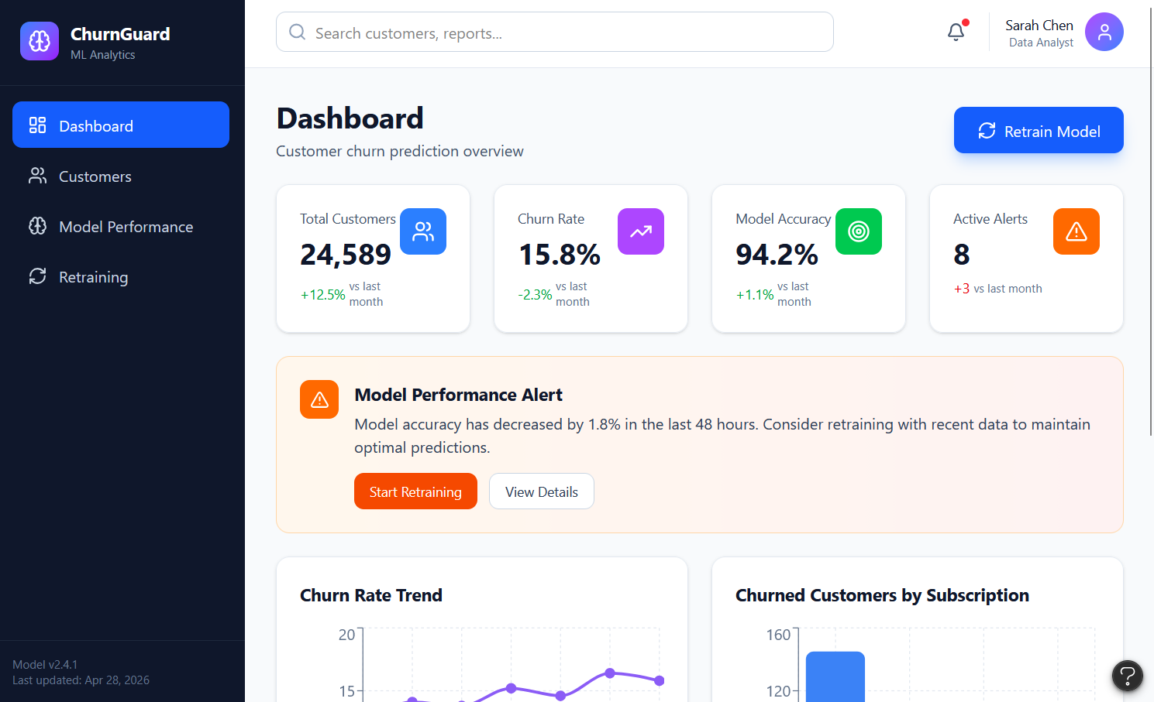
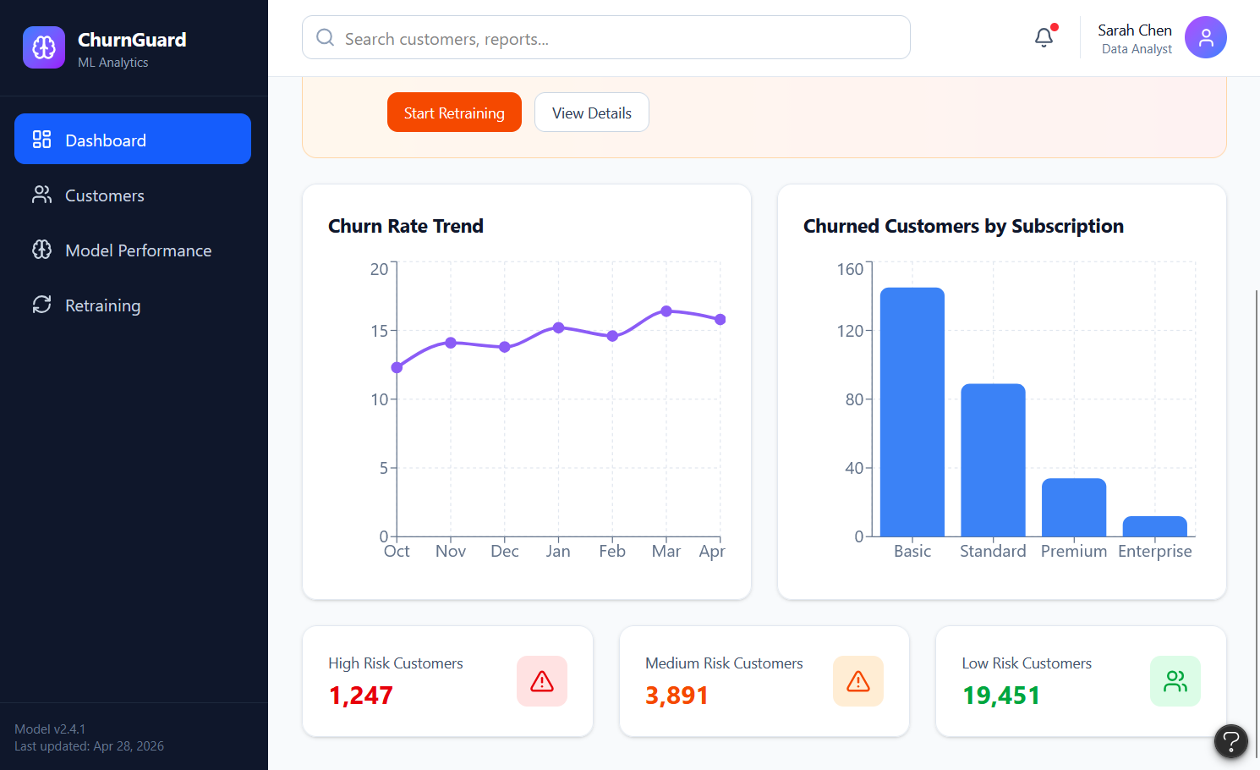

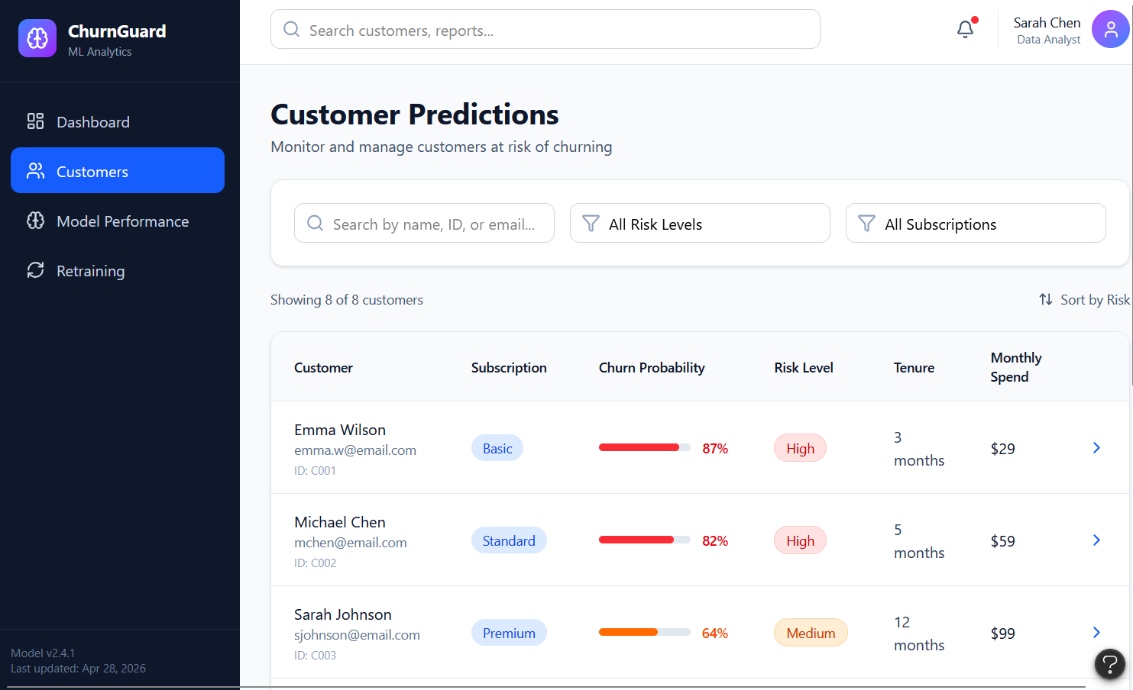

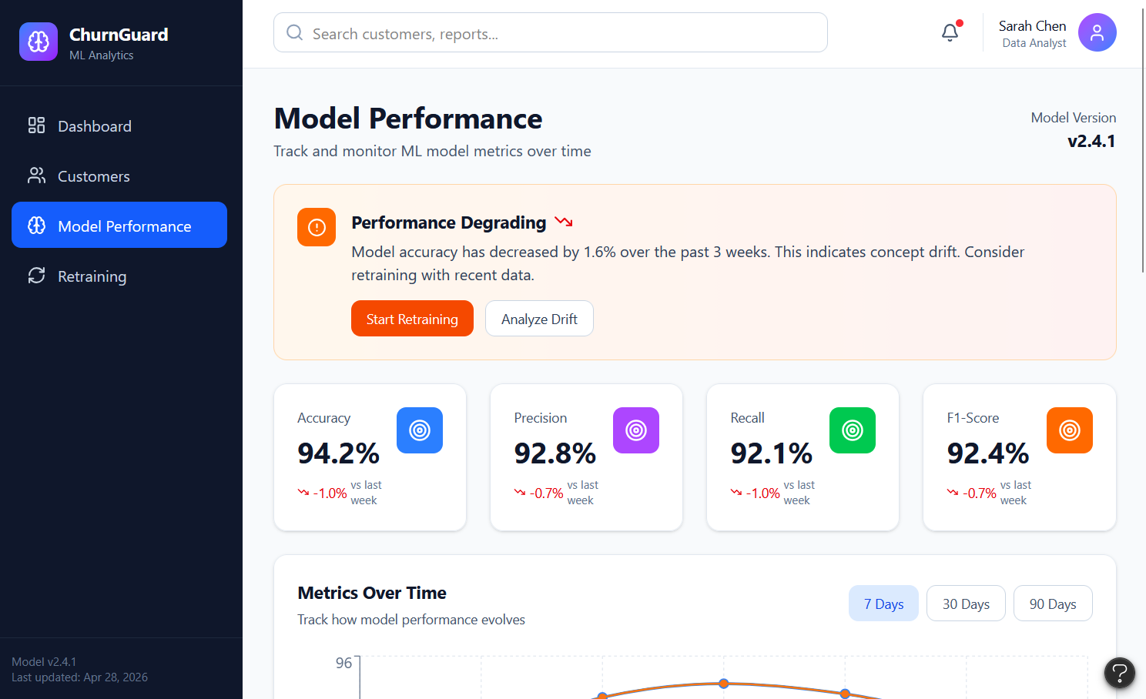

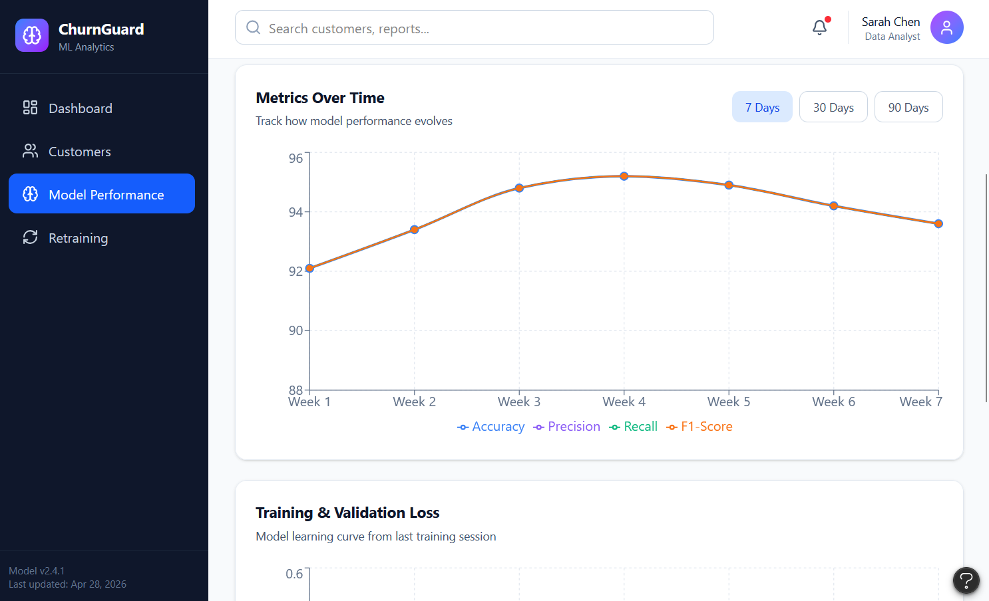

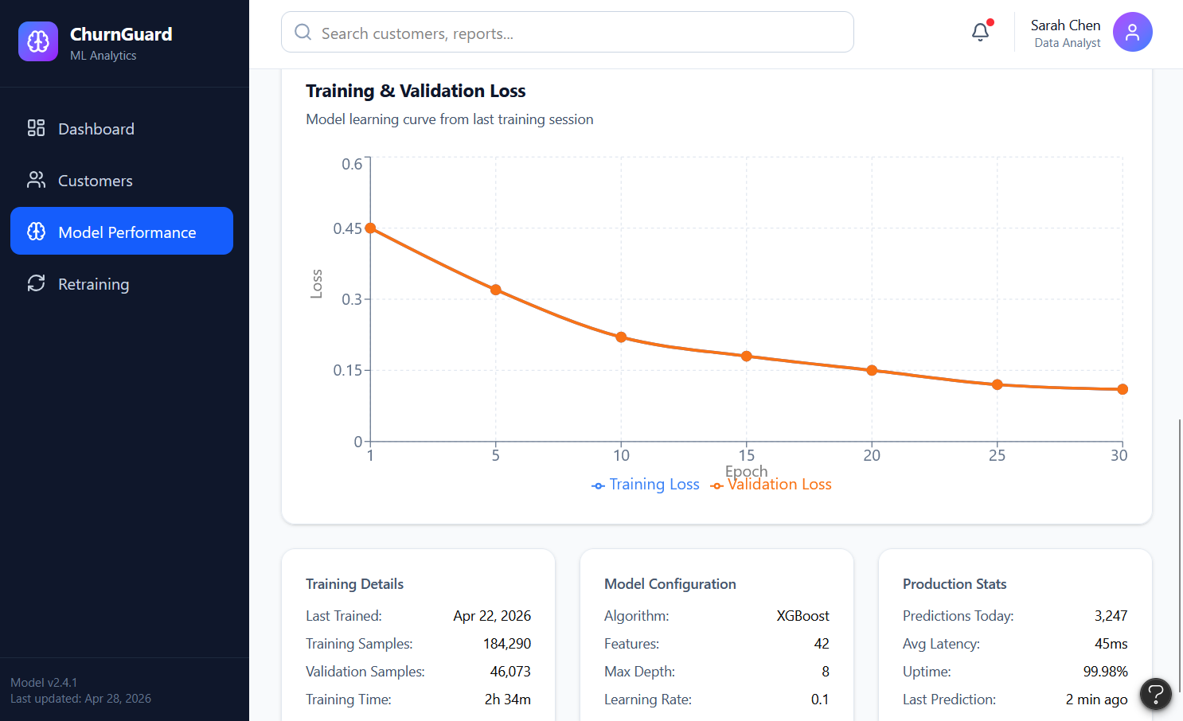

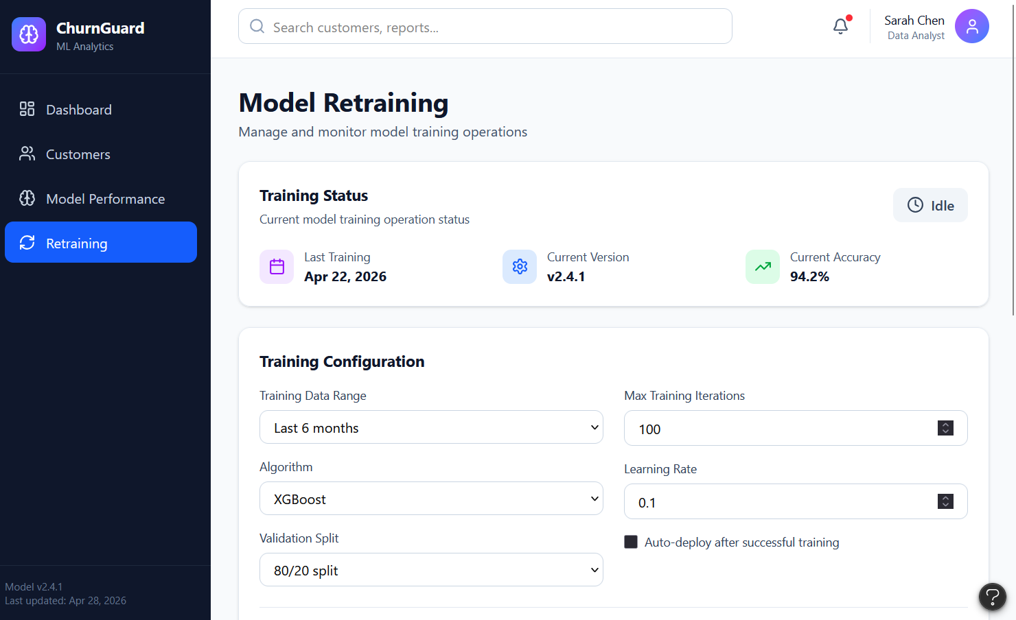
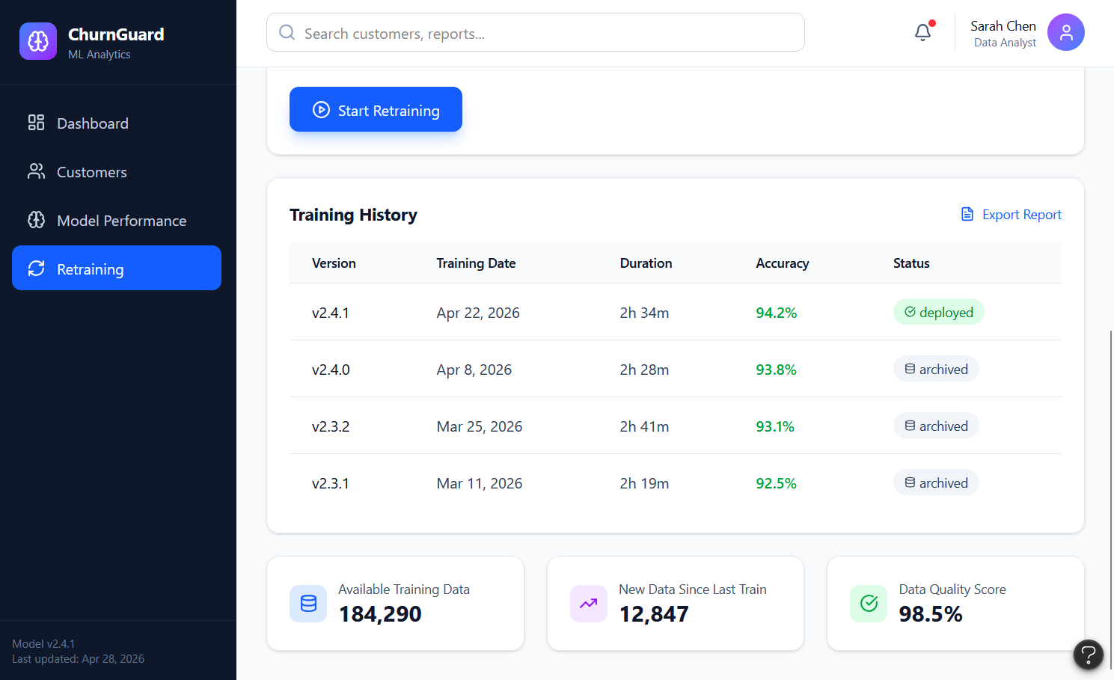

4. System Deployment & Integration

Technology Stack Outline
Churn Prediction MLOps System · Telecom Dataset
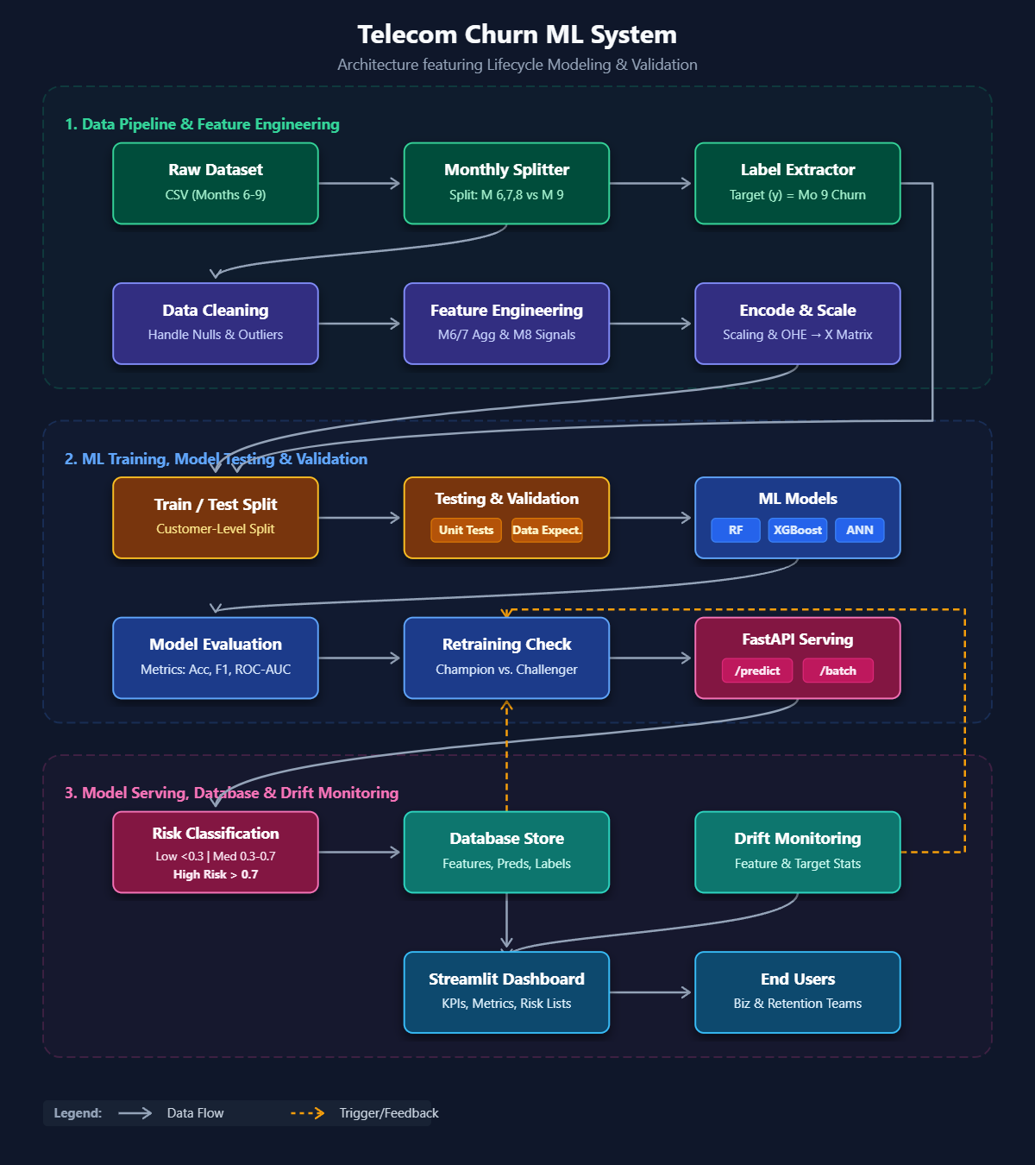

A · Data Layer
Ingest the Telecom Customer Churn Dataset from Kaggle. Raw and processed data resides in Azure Data Lake. Apache Spark handles batch feature engineering at scale; Apache Kafka (optional) supports near-real-time event ingestion.

B · Machine Learning Layer
Models are developed in Python using scikit-learn and XGBoost as primary learners, with TensorFlow available for deep-learning experiments. MLflow tracks experiments, parameters, and model artifacts. Feast serves as the centralised feature store, decoupling feature computation from serving.

C · Backend / API Layer
FastAPI exposes REST endpoints for real-time churn scoring. The business logic layer translates raw model outputs into risk tiers and fires downstream alert triggers for customer retention workflows.

D · MLOps & Automation
Apache Airflow orchestrates the end-to-end pipeline — from data ingestion and feature refresh to model retraining and promotion. GitHub Actions handles CI/CD, running automated tests and deploying updated model artifacts on each merge.

E · Deployment & Infrastructure
Docker containers package all services for reproducible, portable deployments. All services are deployed on Microsoft Azure, leveraging managed services for compute, storage, and networking.
Note: Azure Data Lake inclusion is provisional and most appropriate when the Kafka/Spark streaming path is active. For batch-only workloads, simpler blob storage may suffice.

Telecom Customer Churn Prediction
Deployment Architecture & CI/CD Pipeline
Based on the Kaggle Telecom Customer Churn Dataset

1. Project Overview
This document describes the end-to-end machine learning system built to predict customer churn for a telecommunications provider. The underlying dataset is the Telecom Customer Churn Dataset published on Kaggle, which contains subscriber-level features such as contract type, monthly charges, tenure, internet service tier, and support tickets. A churn label (binary: churned / retained) allows training of a supervised classifier.
The system is deployed entirely on Microsoft Azure, using an AKS (Azure Kubernetes Service) cluster to host all runtime components as Docker containers. A REST API exposes real-time churn scores to CRM and downstream applications, while an automated retraining loop ensures the model adapts to distribution shifts over time.

2. Infrastructure Architecture
The diagram below shows the full Azure-hosted architecture. The system is divided into three

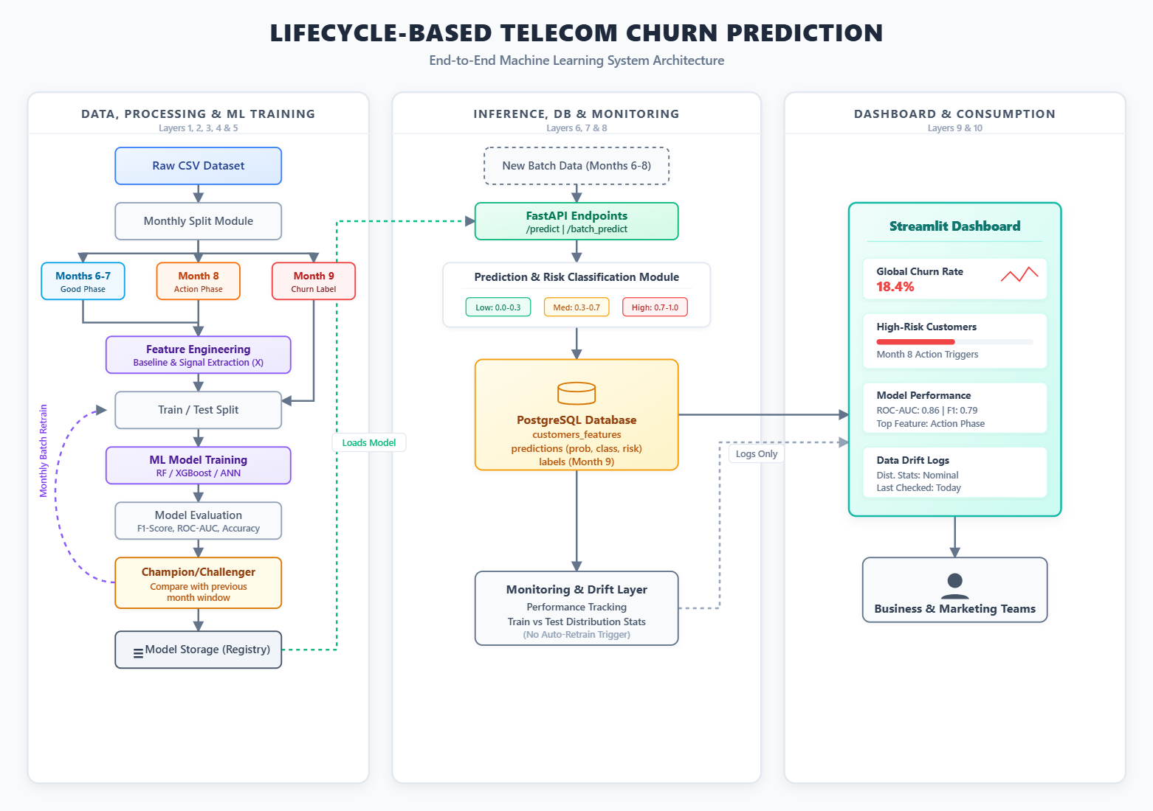
Figure 1 — Azure deployment architecture (AKS cluster, Data Lake, Model Registry, and monitoring)

2.1 AKS Cluster — Runtime Components
All runtime services run as Docker containers orchestrated by AKS:
- FastAPI — exposes the churn scoring endpoint over REST. The CRM and other API consumers call this service synchronously to receive a churn probability for a given subscriber.
- MLflow — tracks all training experiments, including hyperparameter sets, evaluation metrics, and model artifacts. Every retrain run is logged here before promotion.
- Airflow — orchestrates the retraining pipeline as a DAG (Directed Acyclic Graph). It is triggered either on a schedule or automatically when Azure Monitor detects model drift.
- Model Container — houses the active XGBoost / scikit-learn model. The container is replaced via a rolling update whenever a newly retrained model is promoted from the registry.
- Kafka Consumer (optional, streaming path) — listens to a live event stream and triggers retraining when event volume reaches a configurable threshold. This path is activated only when near-real-time adaptation is required.

2.2 Azure Data Lake
The Data Lake serves as the single source of truth for all data assets. It stores raw ingested records from the telecom data source, processed and feature-engineered snapshots, and versioned training datasets that Airflow uses when launching a retrain run.

2.3 Model Registry (MLflow Artifact Store)
Every model trained by the pipeline is versioned in the MLflow-backed model registry. Promotion gates enforce quality checks (e.g., AUC threshold, data-drift score) before a candidate model is allowed to replace the production container. This prevents degraded models from reaching the scoring endpoint even if a retraining DAG completes successfully.

2.4 Azure Monitor + Application Insights
Observability is centralized in Azure Monitor with Application Insights. Key signals monitored include:
- Model drift — statistical divergence between the training feature distribution and the live inference distribution.
- API latency — p50/p95/p99 response times for the Fast API scoring endpoint.
- Container health — CPU, memory, and restart counts for all AKS pods.
When drift exceeds a configurable threshold, Azure Monitor publishes an alert to the Alerts channel (email / PagerDuty) and automatically triggers the Airflow retraining DAG, closing the feedback loop without manual intervention.

3. CI/CD Pipeline
The diagram below illustrates the four-stage pipeline that governs every code change from a developer commit through to a live deployment.

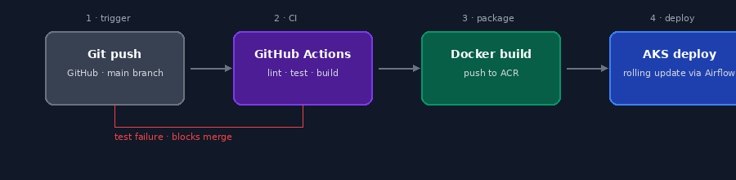
Figure 2 — CI/CD pipeline: Git push → GitHub Actions → Docker build → AKS deploy

3.1 Stage 1 — Trigger (Git Push)
A push to the main branch on GitHub initiates the pipeline. Feature branches are not deployed directly; they must be merged via a pull request, which itself is blocked if the CI stage reports a failure.

3.2 Stage 2 — CI (GitHub Actions)
GitHub Actions runs three sequential checks: linting (code style and static analysis), unit and integration tests, and a build verification step. A test failure stops the pipeline immediately and blocks the merge, ensuring that only passing code progresses.

3.3 Stage 3 — Package (Docker Build)
On a successful CI run, the application is packaged into a Docker image and pushed to Azure Container Registry (ACR). Each image is tagged with the Git commit SHA for full traceability between a running container and the source revision that produced it.

3.4 Stage 4 — Deploy (AKS Rolling Update)
Airflow coordinates the final deployment step. It instructs AKS to perform a rolling update, incrementally replacing old pods with the new image while preserving availability. If the new pods fail their readiness probe, the rollout is automatically halted and the previous version remains active.

4. End-to-End Data Flow
The following summarizes how data moves through the system from ingestion to a live prediction:
- Raw subscriber data is ingested from the Telecom data source into the Azure Data Lake.
- Airflow DAGs read from the Data Lake, apply feature engineering, and write processed snapshots back to the lake.
- The Model Container is trained on the processed dataset. MLflow logs the run; the model is pushed to the registry if it passes promotion gates.
- Fast API serves the promoted model. CRM systems query the endpoint via REST to receive churn probabilities in real time.
- Azure Monitor continuously watches for drift and latency anomalies, triggering automatic retraining via Airflow when thresholds are breached.

5. Key Design Decisions

Drift-triggered retraining
Rather than retraining on a fixed schedule, the system retrains reactively when statistical drift is detected in production traffic. This reduces unnecessary compute while ensuring the model responds quickly to real behavioral shifts in the subscriber population.

Promotion gates in the model registry
Automated quality gates prevent degraded models from entering production even when a retraining run completes. This decouples the retraining cadence from the deployment cadence, allowing frequent experimentation without risk to live predictions.

Optional Kafka streaming path
The Kafka consumer is architecturally optional. Deployments that do not require near-real-time event-driven retraining can omit this component, reducing operational complexity while retaining the capability to enable it when subscriber beسhaviour is highly dynamic.

Rolling deployments via Airflow
Using Airflow as the deployment coordinator means the same orchestration tool that manages data pipelines also governs model rollouts. This simplifies the operational footprint and allows pipeline-aware deployment logic, such as blocking a rollout if a retraining DAG is still running.

5. Testing & Validation
